

Industrial Internship Report on
”Forecasting of Smart City Traffic Patterns”
Prepared by
Ruchi Jadhav

Executive Summary
This report provides details of the Industrial Internship provided by upskill Campus and The IoT Academy in collaboration with the Industrial Partner UniConverge Technologies Pvt. Ltd. (UCT).
This internship was focused on a project/problem statement provided by UCT. We had to complete the project, including the report, within a period of 6 weeks.
My project was “Forecasting of Smart City Traffic Patterns.” The project focused on using Machine Learning to analyze historical traffic data and predict the number of vehicles at a particular junction based on factors such as junction, date, time, month, year, and day of the week. A Random Forest Regression model was developed and integrated with a Streamlit dashboard to provide traffic predictions and classify the predicted traffic as Low, Moderate, or Heavy.
This internship gave me a very good opportunity to gain exposure to real-world industrial problems and to design and implement a practical solution using Machine Learning and Python. It helped me improve my skills in data preprocessing, exploratory data analysis, machine learning, model evaluation, visualization, and deployment. Overall, it was a great learning experience and provided valuable practical exposure to the process of developing and deploying a complete machine learning project.




TABLE OF CONTENTS
Sr. No. | Content | Page No.
1 | Preface | 4
2 | Introduction  - About UniConverge Technologies Pvt. Ltd.  - About upskill Campus (USC)  - The IoT Academy  - Objectives of this Internship Program  - Reference  - Glossary | 5
3 | Problem Statement | 14
4 | Existing and Proposed Solution  - Code Submission (GitHub Link)  - Report Submission (GitHub Link) | 15
5 | Proposed Design / Model  - Design Flow  - Interfaces | 17
6 | Performance Test  - Test Plan / Test Cases  - Test Procedure  - Performance Outcome | 21
7 | My Learnings | 24
8 | Future Work Scope | 25


Preface
This six-week Industrial Internship provided me with an opportunity to apply my academic knowledge to a real-world problem. My project, “Forecasting of Smart City Traffic Patterns,” focused on using Machine Learning to predict traffic at different junctions.
The internship was valuable for my career development as it gave me practical exposure to Python, data analysis, Machine Learning, visualization, and Streamlit deployment.
The program was planned in stages, including understanding the problem and dataset, data preprocessing, EDA, model development, evaluation, and deployment. I developed a Random Forest Regression model and an interactive Streamlit dashboard for traffic prediction.
I would like to thank upskill Campus, The IoT Academy, UniConverge Technologies Pvt. Ltd. (UCT), my mentors, faculty members, coordinators, and peers for their guidance and support throughout the internship.
I encourage my juniors and peers to actively participate in such opportunities, learn beyond academics, and gain practical experience by working on real-world projects.
Overall, this internship was a valuable learning experience that improved my technical, analytical, and problem-solving skills.


Introduction

About UniConverge Technologies Pvt Ltd
A company established in 2013 and working in Digital Transformation domain and providing Industrial solutions with prime focus on sustainability and RoI.
For developing its products and solutions it is leveraging various Cutting Edge Technologies e.g. Internet of Things (IoT), Cyber Security, Cloud computing (AWS, Azure), Machine Learning, Communication Technologies (4G/5G/LoRaWAN), Java Full Stack, Python, Front end etc.

- UCT IoT Platform ()
UCT Insight is an IOT platform designed for quick deployment of IOT applications on the same time providing valuable “insight” for your process/business. It has been built in Java for backend and ReactJS for Front end. It has support for MySQL and various NoSql Databases.
- It enables device connectivity via industry standard IoT protocols - MQTT, CoAP, HTTP, Modbus TCP, OPC UA
- It supports both cloud and on-premises deployments.
It has features to
• Build Your own dashboard
• Analytics and Reporting
• Alert and Notification
• Integration with third party application(Power BI, SAP, ERP)
• Rule Engine


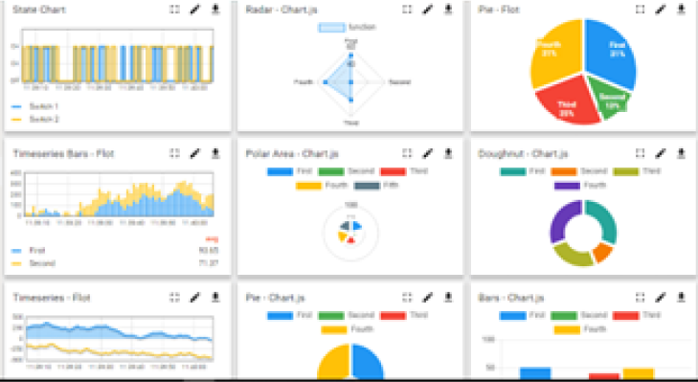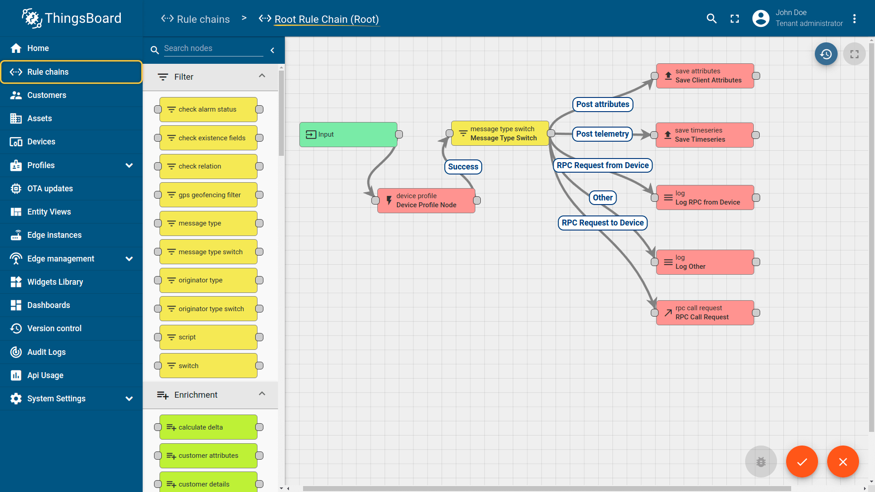

- Smart Factory Platform ()
Factory watch is a platform for smart factory needs.

It provides Users/ Factory
- with a scalable solution for their Production and asset monitoring
- OEE and predictive maintenance solution scaling up to digital twin for your assets.
- to unleased the true potential of the data that their machines are generating and helps to identify the KPIs and also improve them.
- A modular architecture that allows users to choose the service that they what to start and then can scale to more complex solutions as per their demands.
Its unique SaaS model helps users to save time, cost and money.

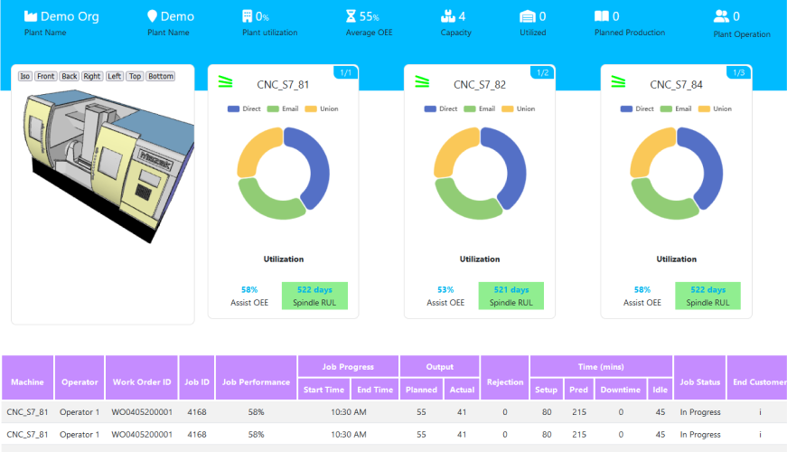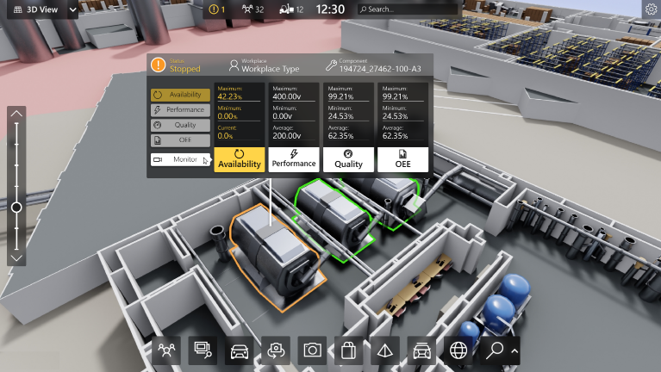


- 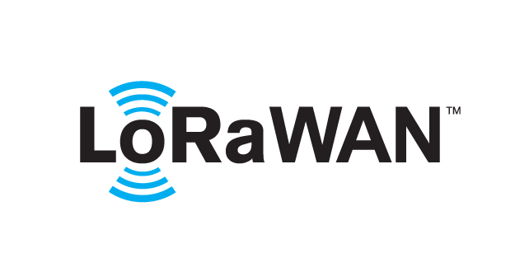 based Solution
UCT is one of the early adopters of LoRAWAN teschnology and providing solution in Agritech, Smart cities, Industrial Monitoring, Smart Street Light, Smart Water/ Gas/ Electricity metering solutions etc.
- Predictive Maintenance
UCT is providing Industrial Machine health monitoring and Predictive maintenance solution leveraging Embedded system, Industrial IoT and Machine Learning Technologies by finding Remaining useful life time of various Machines used in production process.
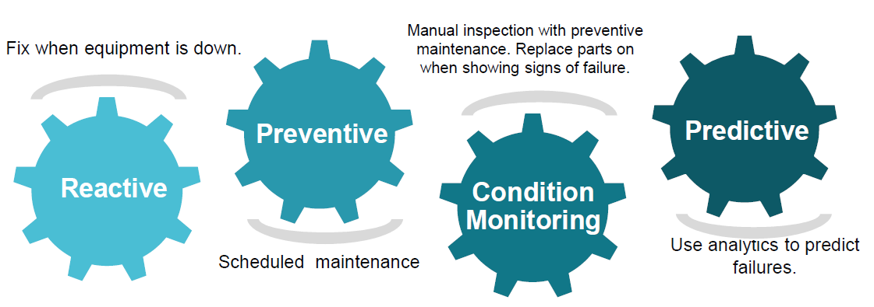

About upskill Campus (USC)
upskill Campus along with The IoT Academy and in association with Uniconverge technologies has facilitated the smooth execution of the complete internship process.
USC is a career development platform that delivers personalized executive coaching in a more affordable, scalable and measurable way.





Seeing need of upskilling in self paced manner along-with additional support services e.g. Internship, projects, interaction with Industry experts, Career growth Services
https://www.upskillcampus.com/

upSkill Campus aiming to upskill 1 million learners in next 5 year

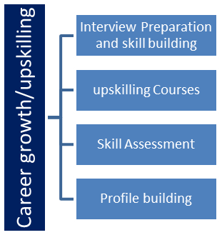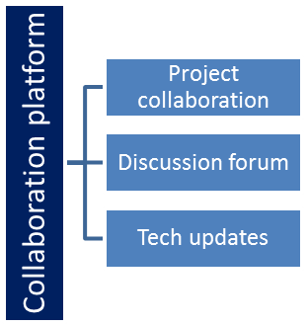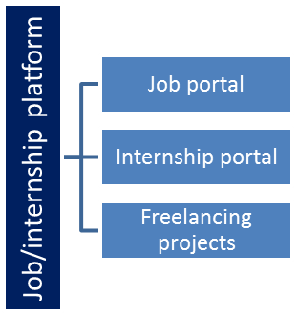


The IoT Academy
The IoT academy is EdTech Division of UCT that is running long executive certification programs in collaboration with EICT Academy, IITK, IITR and IITG in multiple domains.

Objectives of this Internship program
The objective for this internship program was to
☛ get practical experience of working in the industry.
☛ to solve real world problems.
☛ to have improved job prospects.
☛ to have Improved understanding of our field and its applications.
☛ to have Personal growth like better communication and problem solving.

Reference
- UniConverge Technologies Pvt. Ltd. (UCT) – Project Problem Statement and Internship Guidelines.
- upskill Campus and The IoT Academy – Internship Program Materials.
- Python Documentation – Python programming and data handling.
- Scikit-learn Documentation – Random Forest Regression and model evaluation.
- Streamlit Documentation – Development and deployment of the interactive dashboard.
- Plotly Documentation – Data visualization.
- Project dataset provided for the internship.

Glossary
Terms | Acronym
EDA | Exploratory Data Analysis
MAE | Mean Absolute Error
R² | R-squared score used to evaluate model performance
API | Application Programming Interface
Streamlit | Framework used to create the interactive web dashboard



Problem Statement
The assigned problem statement was “Forecasting of Smart City Traffic Patterns.”
The main objective of this project was to develop a Machine Learning-based system that can forecast the number of vehicles at different traffic junctions using historical traffic data. Traffic conditions vary depending on factors such as junction, date, time, month, year, and day of the week, making accurate prediction useful for smart city traffic management.
The project involved analyzing the available historical traffic dataset, performing data preprocessing and Exploratory Data Analysis (EDA), and extracting useful features from the date and time information. A Random Forest Regression model was then trained to learn patterns from the historical data and predict future traffic levels.
The developed model achieved an MAE of 10.83 and an R² Score of 0.712. To make the system user-friendly, the model was integrated into an interactive Streamlit dashboard. Users can select a junction, date, time, and other parameters to obtain the predicted vehicle count. The dashboard also categorizes the predicted traffic into Low, Moderate, or Heavy traffic.
Thus, the project demonstrates how Machine Learning can be applied to historical traffic data to build a practical smart traffic forecasting solution.


Existing and Proposed solution

- Existing Solution
Traditional traffic management systems mainly rely on historical traffic records, fixed monitoring, and manual analysis to understand traffic conditions. These approaches can provide information about past traffic patterns but may have limitations in predicting traffic for a specific junction and time.
Limitations:
- Limited ability to predict future traffic accurately.
- Manual analysis can be time-consuming.
- Traffic patterns may change based on time and junction.
- Difficult to provide quick predictions for different conditions.
- Proposed Solution
The proposed solution uses Machine Learning to analyze historical traffic data and predict the number of vehicles at a particular junction. A Random Forest Regression model is trained using features such as junction, year, month, day, hour, and day of the week.
The model is integrated with a Streamlit dashboard, where users can enter the required details and receive a predicted vehicle count along with a traffic category such as Low, Moderate, or Heavy.
- Value Addition
The proposed system adds value by providing:
- Automated traffic prediction using Machine Learning.
- Interactive dashboard for easy use.
- Prediction based on multiple time and junction-related features.
- Traffic-level classification for easier interpretation.
- Visualizations to understand traffic patterns and feature importance.
- A practical foundation for future smart city traffic management systems.


Code submission (Github link)
https://github.com/rj3005006-ui/upskillcampus.git

Report submission (Github link) : first make placeholder, copy the link.


Proposed Design/ Model

The proposed system follows a step-by-step Machine Learning workflow to forecast traffic patterns.
Design Flow:
Historical Traffic Dataset
↓
Data Preprocessing
↓
Feature Extraction
↓
Exploratory Data Analysis (EDA)
↓
Train Random Forest Regression Model
↓
Evaluate Model Performance
↓
Save Trained Model
↓
Streamlit Dashboard
↓
User Inputs → Traffic Prediction → Traffic Status


Interfaces (if applicable)
1.Block Diagram
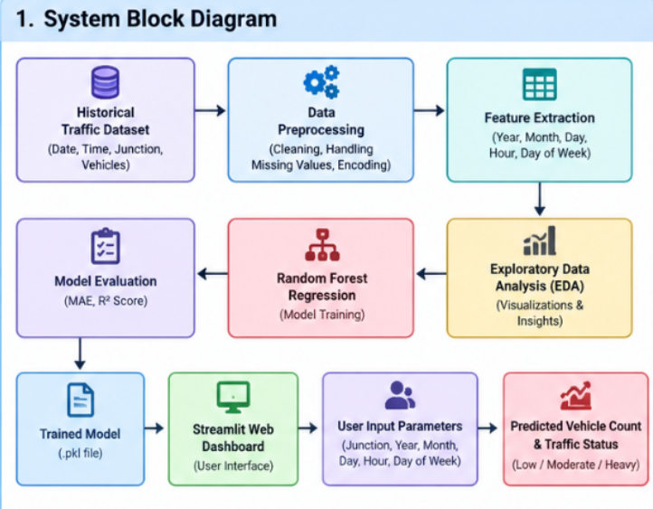

2.Data Flow Diagram
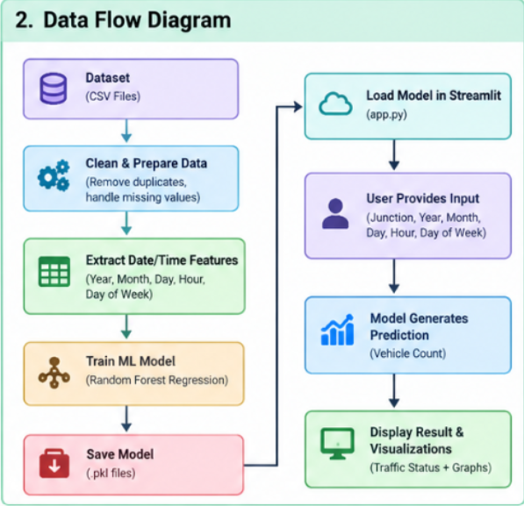


3.Flow Chart
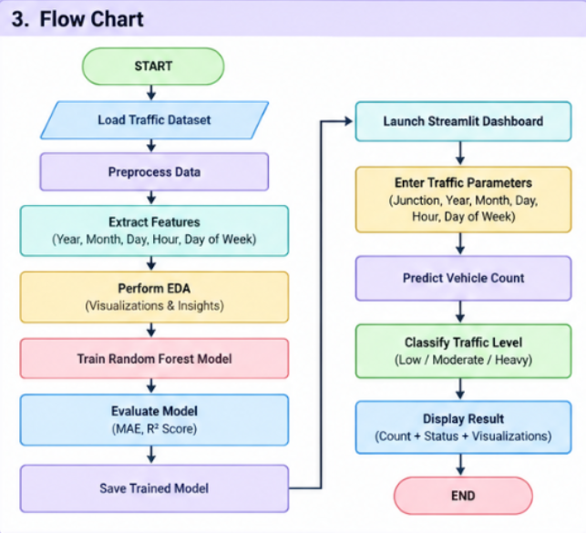

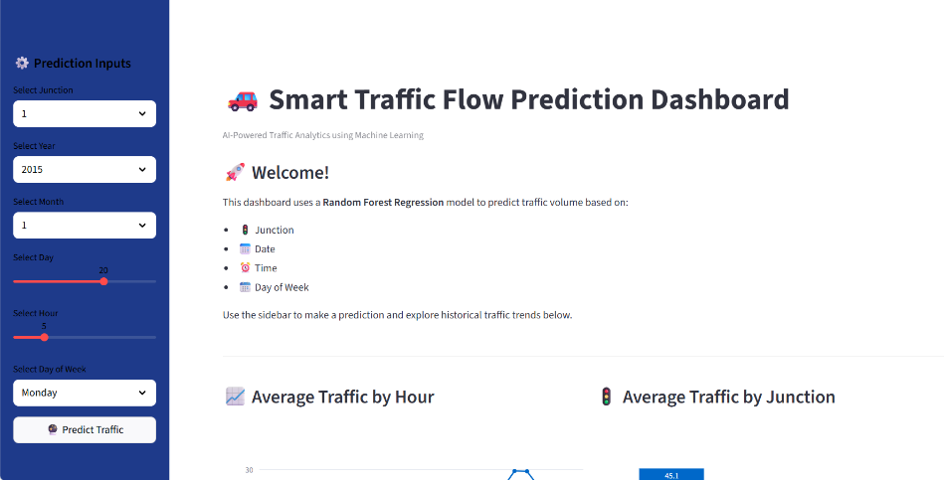
4.User Interface

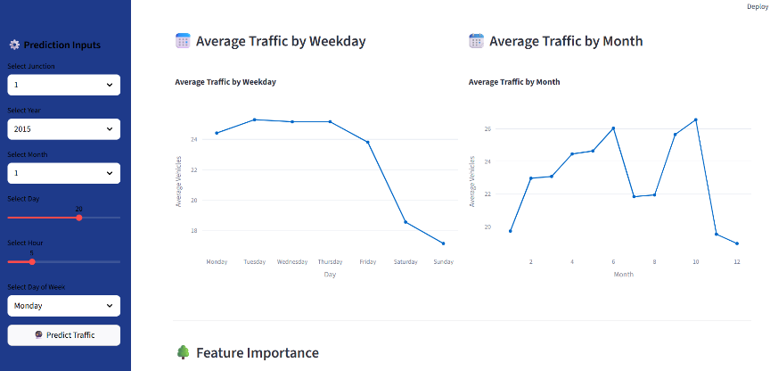
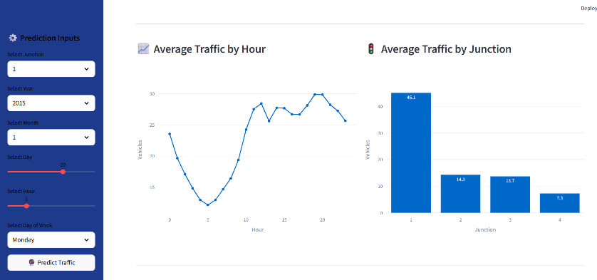
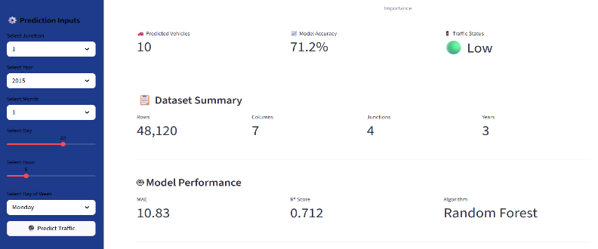
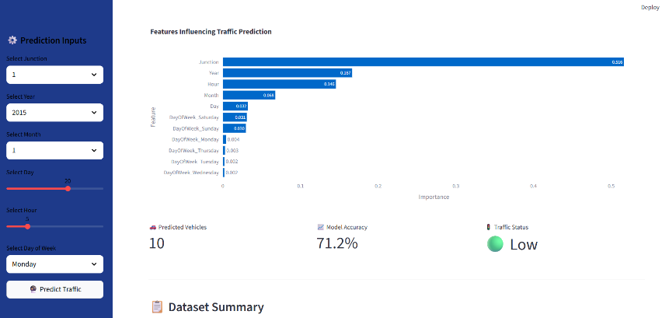



Performance Test

Performance testing was carried out to check whether the proposed traffic prediction system could provide reliable predictions and work effectively as a practical application.
- Identified Constraints
The major constraints considered in the project were:
- Prediction performance: The model should provide reasonably accurate traffic predictions.
- Processing time: Predictions should be generated quickly after user input.
- Model size: The trained Machine Learning model was large, creating limitations for direct storage on GitHub.
- Usability: The prediction system should be simple and accessible to users.
- How the Constraints Were Handled
A Random Forest Regression model was selected and evaluated using Mean Absolute Error (MAE) and R² Score. The trained model was integrated with a Streamlit dashboard to provide predictions interactively.
Due to the large size of the trained .pkl model, it was stored on Hugging Face, while the application code and supporting files were maintained on GitHub. The Streamlit application downloads the model when required.
- Test Results
The final model achieved:
Metric | Result
MAE | 10.83
R² Score | 0.712
An MAE of 10.83 indicates that the model's predictions differ from the actual traffic count by an average of approximately 10.83 units. The R² Score of 0.712 indicates that the model explains approximately 71.2% of the variation in the target traffic data.

The application successfully accepts user inputs and generates a traffic prediction along with a Low, Moderate, or Heavy traffic classification.
- Recommendations
Further improvement can be achieved through hyperparameter tuning, additional features such as weather and special events, real-time traffic data, and testing of other Machine Learning algorithms. These improvements could help increase prediction performance and make the system more suitable for real-world smart city applications.

11.1 Test Plan / Test Cases
The system was tested with different combinations of junction, date, time, and day to verify that it generates predictions correctly.
Test Case | Expected Result
Valid traffic inputs | Vehicle count is predicted
Different junction selected | Prediction changes accordingly
Different time selected | Prediction is generated successfully
Prediction generated | Traffic classified as Low, Moderate, or Heavy
Dashboard opened | Charts and interface load correctly

11.2 Test Procedure
- Open the Streamlit dashboard.
- Enter the required traffic parameters.
- Click the Predict button.
- Check the predicted vehicle count.
- Verify the corresponding traffic status.
- Test different input combinations and observe the results.

11.3 Performance Outcome
The system successfully generated traffic predictions for the given inputs. The Random Forest model achieved an MAE of 10.83 and an R² Score of 0.712. The Streamlit dashboard also successfully displayed predictions, traffic status, and visualizations.


My learnings
During this internship, I gained practical knowledge of Python, data preprocessing, EDA, Machine Learning, Random Forest Regression, model evaluation, and Streamlit.
I learned how to work with a real-world dataset, develop a prediction model, evaluate its performance, and deploy it as an interactive application. I also improved my problem-solving, debugging, and analytical skills.
This experience will help me in my career by giving me a better understanding of real-world Machine Learning projects and increasing my confidence in developing practical solutions.


Future work scope

In the future, the project can be improved by:
- Adding real-time traffic data for live predictions.
- Including factors such as weather, holidays, and special events.
- Applying hyperparameter tuning to improve model performance.
- Testing other Machine Learning algorithms for better predictions.
- Adding traffic alerts and notifications for heavy traffic conditions.
These improvements can make the system more accurate and useful for real-world smart city traffic management.

